**Lab Assignment 3**

1. **R Project**

Prepare a dataset related to your own project and perform k-Means, k-Medians, Expectation Maximisation (EM), Hierarchical Clustering and report the results.

**Description**:



**K-Means**

lab3<-read.csv("lab3.csv")

Lab3<-lab3

Lab3$UNS<-NULL

km<-kmeans(Lab3,4,41)

table(lab3$UNS,km$cluster)

plot(Lab3[c("STG","SCG","STR","LPR","PEG")],col=km$cluster)

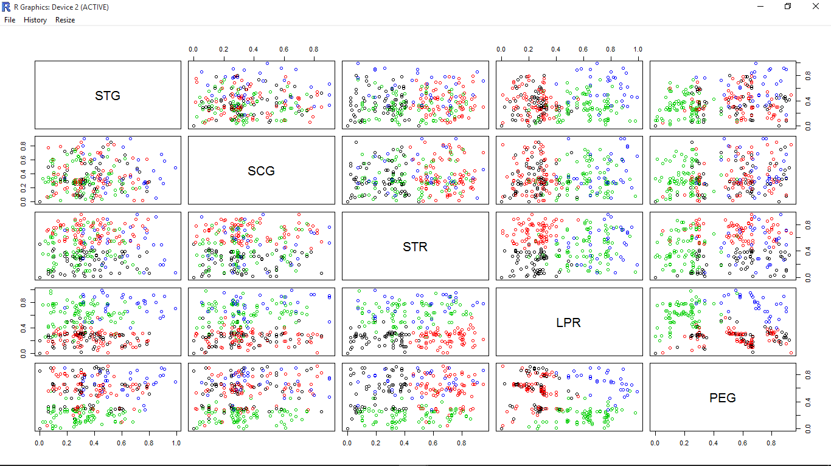

**K-medoids**

library(cluster)

lab3<-read.csv('lab3.csv')

pam.result<-pam(lab3,4)

table(pam.result$clustering,lab3$UNS)

layout(matrix(c(1,2),1,2))

plot(pam.result)

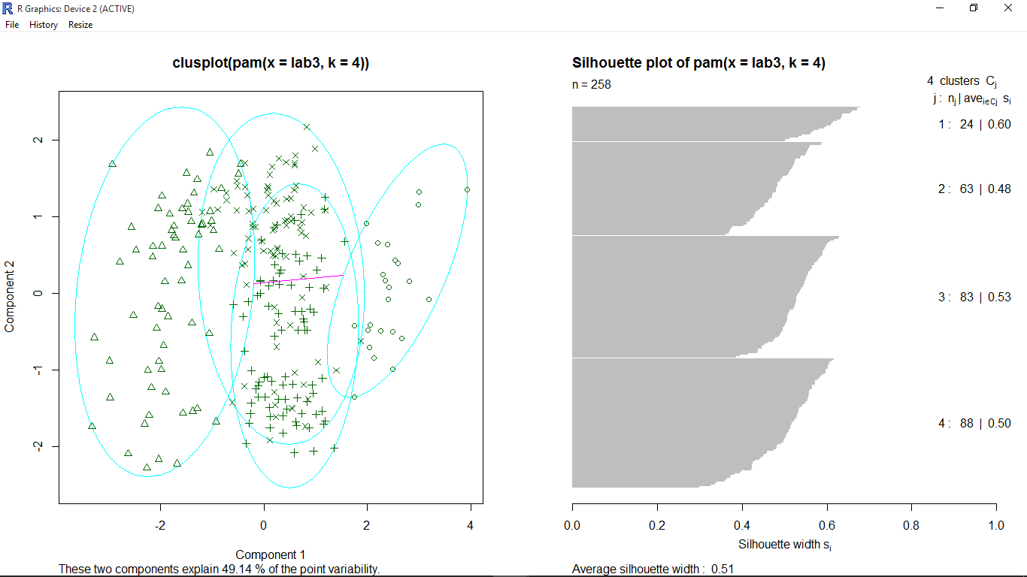

**Expectation Maximization**

library(mclust)

lab3<-read.csv('lab3.csv')

mc<-Mclust(lab3[,1:5],4)

summary(mc)

plot(mc,what="density",dimens=c(1,2))

plot(mc,what="classification",dimens=c(1,2))

table(lab3$UNS,mc$classification)

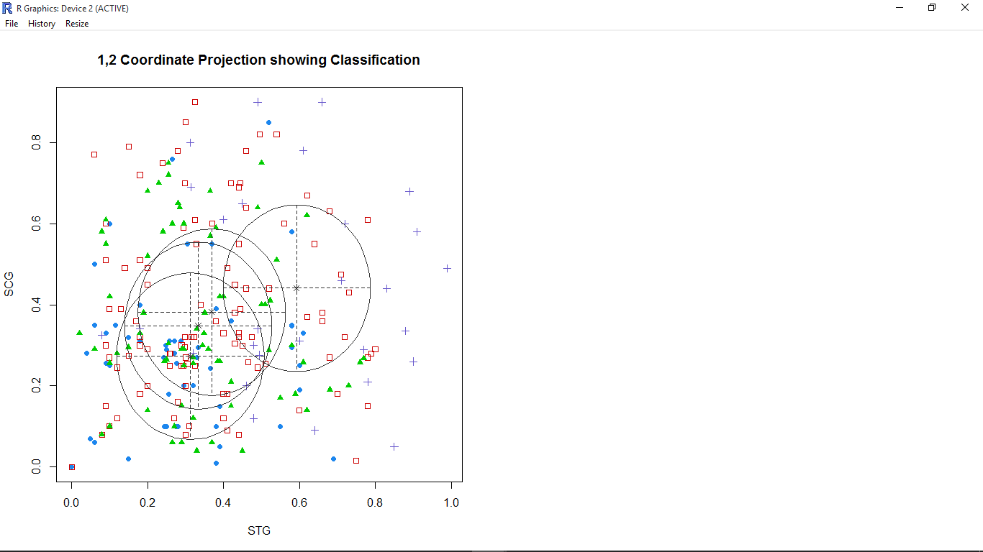

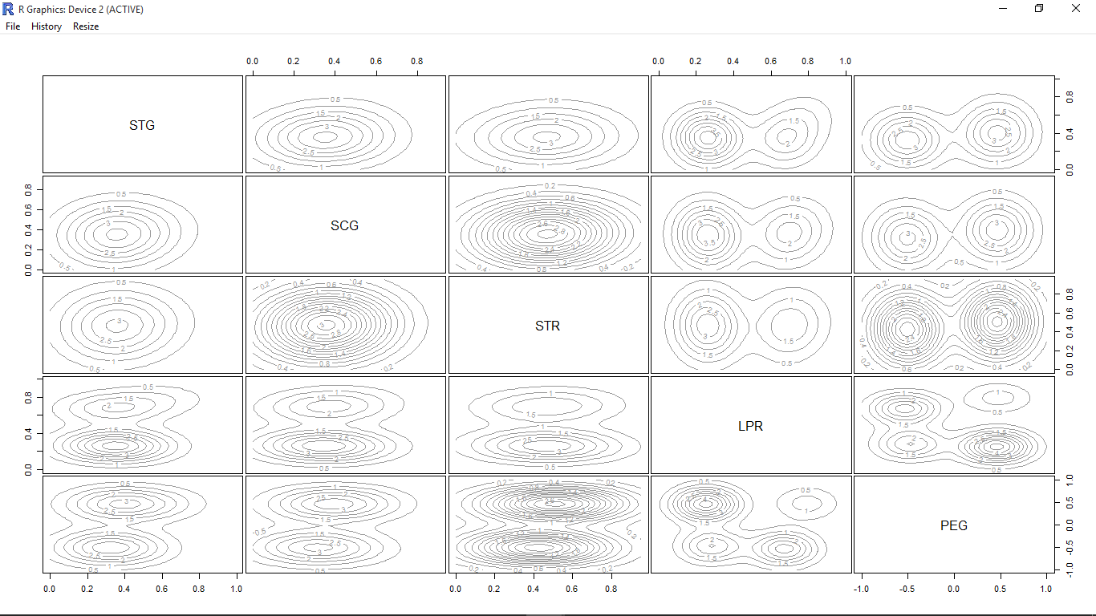

**Hierarchical Clustering**

lab3<-read.csv("lab3.csv")

idx<-sample(1:dim(lab3)[1],50)

Lab3<-lab3[idx,]

Lab3$UNS<-NULL

hc<-hclust(dist(Lab3),method="ave")

plot(hc,hang=-1,labels=Lab3$UNS)

rect.hclust(hc,k=4)

groups<-cutree(hc,k=4)

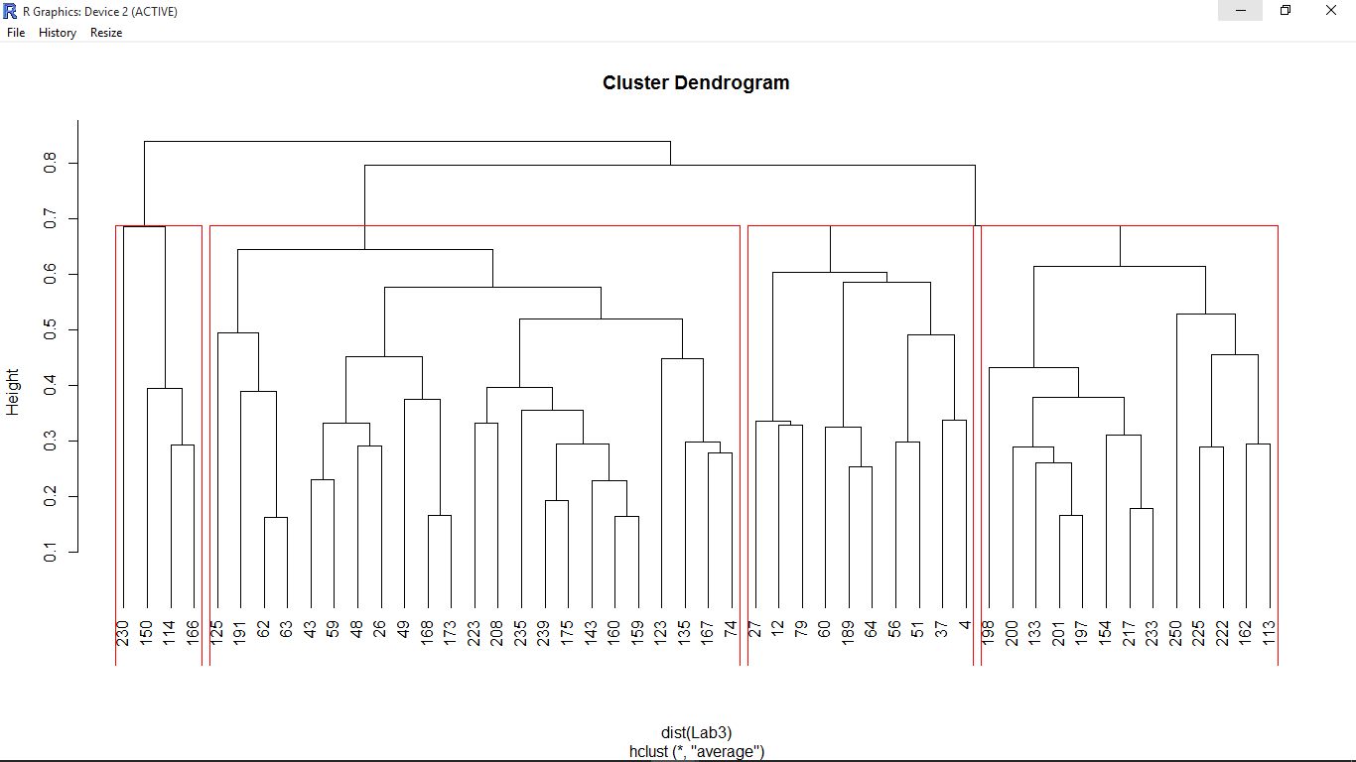

1. **Watch Application**

Data collection related to your own project through Smart Phone and Watch, send notifications to watch using intuitive data analysis.

**Description**: The data is collected through smart phone and is sent as notification to smart watch.

**Screen shots**:

